DEPARTMENT OF ELECTRONIC SYSTEMS
AALBORG UNIVERSITY

7/9 2009 Kim Olesen

Rules for exercises and project work in the laboratories at I8/IES.

The rules in the power current declaration (Section 6, 813) for ”Installations in electrical control rooms” applies for the laboratories. Consequently, it has been decided by the health and safety committee at the Department of Electronic Systems that the following rules must be observed in the laboratories at I8/IES:

- 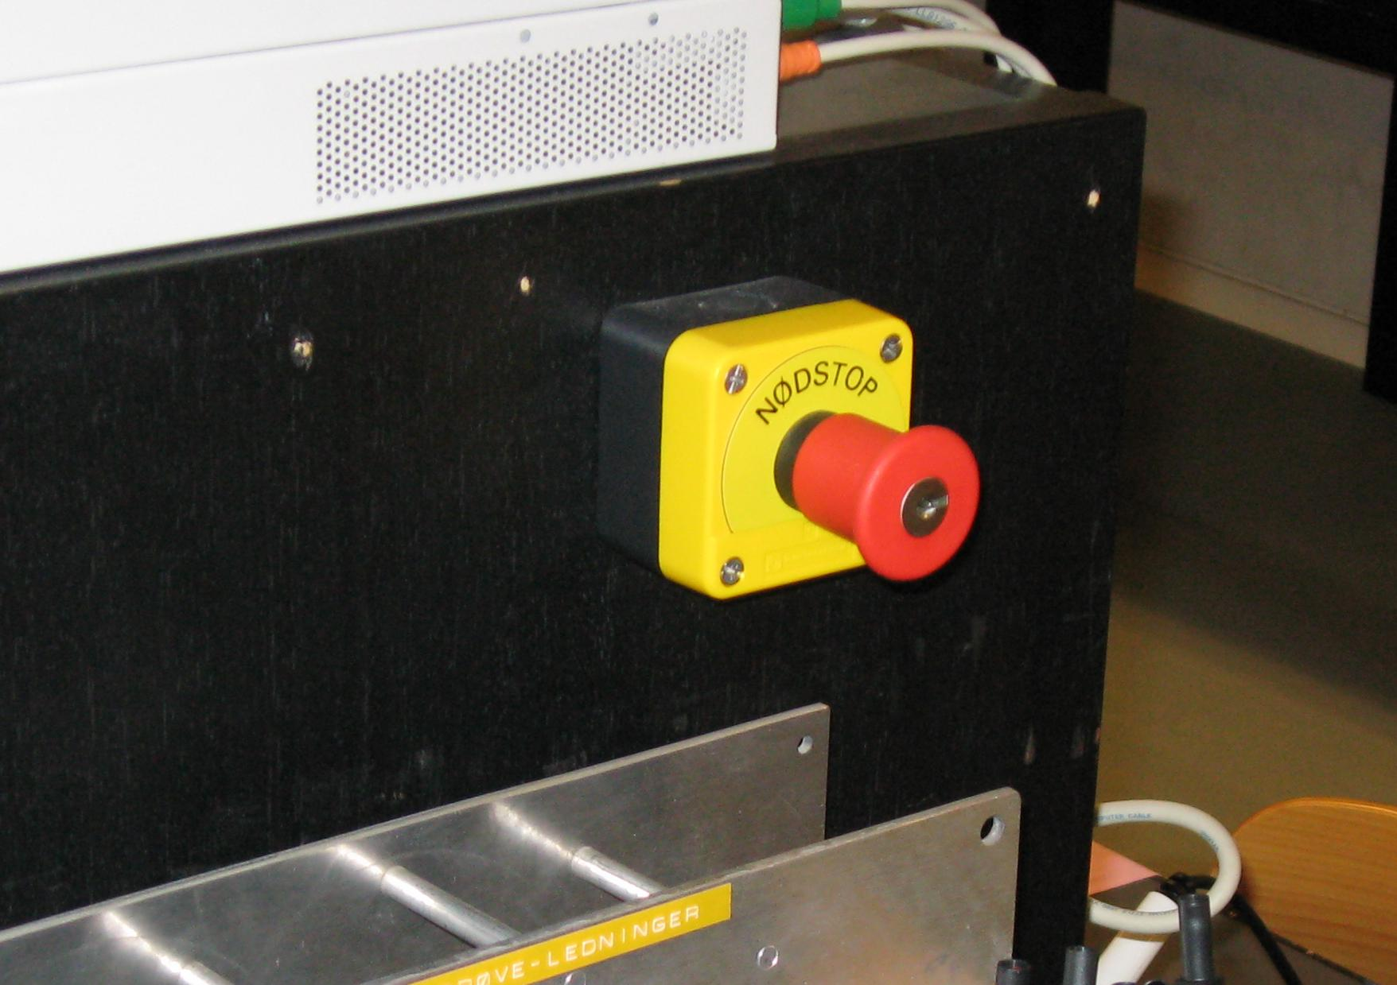If the power is on, at the laboratory installations, everybody present in the room must be Instructed/Skilled personnel, meaning that everybody must have read the below mentioned rules, and been introduced to the laboratory.
- The user must know where the main switch and emergency stop is placed.
- The emergency stop must only be used in emergency situations. The laboratory personnel must be informed if the emergency stop has been activated, before work can be resumed.
- Defect/damaged parts must be handed in for repair.
- It is not allowed to work with direct current voltage (DC) above 60 V.
- It is not allowed to work with alternating current (AC) above 25 V (root mean square value, RMS).
- It is allowed only to use the equipment (instruments, cables, test sticks etc.) belonging to the laboratory, unless the laboratory personnel or the user’s supervisor has approved.
- The laboratory and each single workplace must be clean and tidy at any time. It is not allowed to leave instrument or test cables in an installation that is not connected in both ends.
- If a person gets an electric shock, this must be reported to the laboratory personnel, also even though there is no visible personal injury.
- Electrolyte capacitors must maximum be connected to the voltage stated on the label, and with the correct polarity.
- Laboratory work that may cause special danger (mechanical, chemical, explosion danger etc.) must only be carried out after permission from laboratory personnel and supervisor.
- You must never look directly into LASERs or infrared light emitting diodes (the protection mechanism of the eye does not react on infrared light).
- Soldering - Mounting must only take place at workplaces with an exhaust device.
- It is recommendable to have a liability insurance.
- It is not allowed to work alone in the laboratory.(It is possible to get dispensation after agreement with the supervisor)
- It is a duty to read and understand the rules for every special laboratory.
See them here: http://doc.es.aau.dk/labs/

The undersigned hereby confirm to have read and understood the above-mentioned rules.
Severe neglect of the rules may induce expulsion.

Name/Group:

Date: Signature:

DEPARTMENT OF ELECTRONIC SYSTEMS
AALBORG UNIVERSITY

7/9 2009 Kim Olesen

Rules for exercises and project work in the laboratories at I8/IES.

The rules in the power current declaration (Section 6, 813) for ”Installations in electrical control rooms” applies for the laboratories. Consequently, it has been decided by the health and safety committee at the Department of Electronic Systems that the following rules must be observed in the laboratories at I8/IES:

- If the power is on, at the laboratory installations, everybody present in the room must be Instructed/Skilled personnel, meaning that everybody must have read the below mentioned rules, and been introduced to the laboratory.
- The user must know where the main switch and emergency stop is placed.
- The emergency stop must only be used in emergency situations. The laboratory personnel must be informed if the emergency stop has been activated, before work can be resumed.
- Defect/damaged parts must be handed in for repair.
- It is not allowed to work with direct current voltage (DC) above 60 V.
- It is not allowed to work with alternating current (AC) above 25 V (root mean square value, RMS).
- It is allowed only to use the equipment (instruments, cables, test sticks etc.) belonging to the laboratory, unless the laboratory personnel or the user’s supervisor has approved.
- The laboratory and each single workplace must be clean and tidy at any time. It is not allowed to leave instrument or test cables in an installation that is not connected in both ends.
- If a person gets an electric shock, this must be reported to the laboratory personnel, also even though there is no visible personal injury.
- Electrolyte capacitors must maximum be connected to the voltage stated on the label, and with the correct polarity.
- Laboratory work that may cause special danger (mechanical, chemical, explosion danger etc.) must only be carried out after permission from laboratory personnel and supervisor.
- You must never look directly into LASERs or infrared light emitting diodes (the protection mechanism of the eye does not react on infrared light).
- Soldering - Mounting must only take place at workplaces with an exhaust device.
- It is recommendable to have a liability insurance.
- It is not allowed to work alone in the laboratory.(It is possible to get dispensation after agreement with the supervisor)
- It is a duty to read and understand the rules for every special laboratory.
See them here: http://doc.es.aau.dk/labs/

